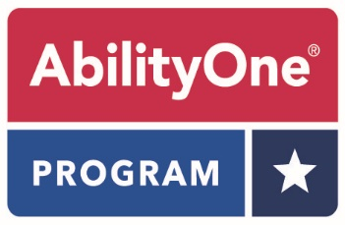

Essentially The Same (ETS) Challenge Form

Date:

Organization Name:

City/State:

This form is required to submit an ETS challenge. Please fill out all required fields and email the completed form to operationsinfo@abilityone.gov. Please include “ETS Challenge” in the subject line. Responses are usually sent within ten (10) business days, although the amount of research required for the response may extend that time frame. A sample of the commercial product will expedite the review process. Please send samples to:

ETS Program Manager
National Industries for the Blind
3000 Potomac Avenue
Alexandria, VA 22305

- Commercial Product Name: _______________________________________

- Commercial Product SKU/Item Number: _____________________________

- Name and URL of catalog where product appears: _________________________

- Catalog Page Number: ____________________________________________

- AbilityOne NSN: _________________________________________________

Please provide a detailed description of your challenge (price is not a valid challenge):

Submitted by:

Name: _________________________________________________________________________________

Signature: _____________________________________________________________________________

Title: ___________________________________________________________________________________

Date: ___________________________________________________________________________________

Phone: _________________________________________________________________________________

Email: _________________________________________________________________________________

